数学与计算机学院计算机系实验报告
课程名称： 数据库系统 | 年级： | 实验成绩：
指导教师： | 姓名： | 实验教室：
实验名称：Transact-SQL语句的高级应用 | 学号： | 实验日期：
实验序号：实验6 | 实验时间：8:00—11:40 | 实验学时：2

撰写说明：填写上面相关栏目，须作相应修改。
仔细阅读：最后“六、提交文档要求”有关说明。
一、实验目的
1. 掌握多表连接查询、子查询、游标、大对象类型数据的基本概念。
2. 掌握多表连接的各种方法，包括内连接、外链接和交叉连接等。
3. 掌握子查询的方法，包括相关子查询和不相关子查询。
4.掌握游标处理结果集的基本过程。
二、实验环境
1. 操作系统：Windows XP
2. 开发软件：SQL Server 2008
三、实验内容（将实验操作步骤写在题目下面）
1.查询所有班级的期末成绩平均分，并按照平均分降序排序。
use teaching
go
select classno,avg(final) as '平均分'
from student,score
where student.studentno = score.studentno
group by student.classno
order by 平均分 desc
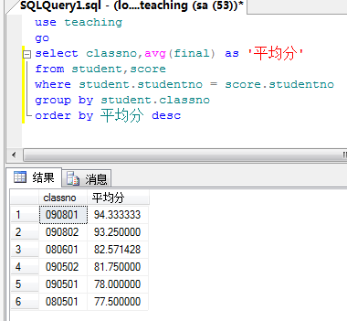
2.查询教师基本信息和教授课程信息，其中包括未分配课程的教师信息。
use teaching
go
select teacher.*,course.cname
from teacher,course,teach_class
where teacher.teacherno = teach_class.teacherno and
teach_class.courseno = course.courseno
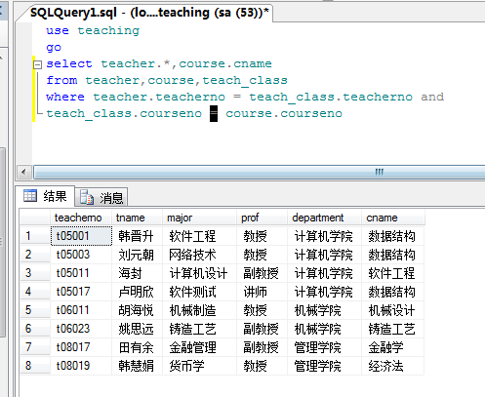
3.查询160501班级中选修了“韩晋升”老师讲授的课程的学生学号、姓名、课程号和期末成绩。
use teaching
go
select student.studentno,student.sname,course.cname,score.final
from student,course,score
where student.studentno = score.studentno and
course.courseno = score.courseno and
student.classno = '090501' and
course.courseno in(select teach_class.courseno
from teacher,teach_class
where teacher.teacherno = teach_class.teacherno and teacher.tname = '韩晋升')
4.查询每门课程的课程号、课程名和选修该课程的学生人数，并按所选人数升序排序。
use teaching
go
select course.courseno,course.cname,count(*) as '学生人数'
from course,student,score
where student.studentno = score.studentno and
course.courseno = score.courseno
group by course.courseno , course.cname
order by 学生人数 asc
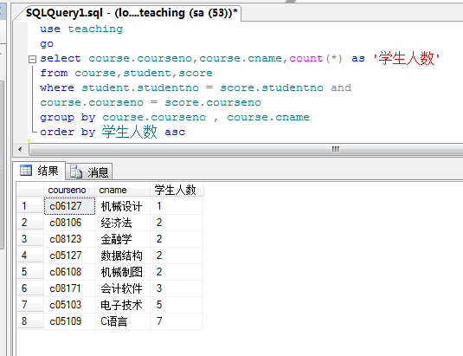
5.查询两门及以上课程的期末成绩超过80分的学生姓名及平均成绩。
use teaching
go
select student.sname,avg(final) as '平均成绩'
from student,score
where final >80 and
student.studentno = score.studentno
group by student.studentno,student.sname
having count(* ) >= 2
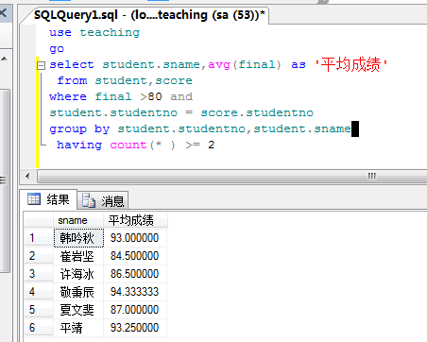
6.查询入学考试成绩最高的学生学号、姓名和入学成绩。
use teaching
go
select studentno, sname, point from student
where studentno=(select top 1 studentno from student order by point)
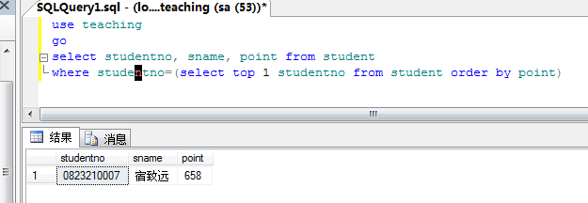
7.查询同时教授c05127号和c05109号课程的教师信息。
use teaching
go
select teacher.teacherno,tname,major,prof,department from teacher join
teach_class on teacher.teacherno=teach_class.teacherno
where courseno in('c05127','c05109')
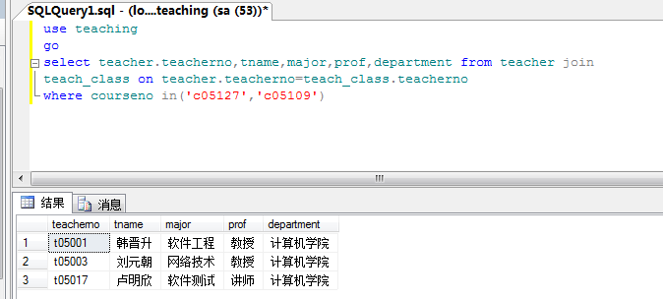
8.查询至少选修了姓名为“韩吟秋”的学生所选修课程中一门课程的学生学号和姓名。
use teaching
go
select student.studentno,sname
from student,teach_class
where student.classno = teach_class.classno and
student.sname != N'韩吟秋' and
teach_class.classno
in(select teach_class.classno from teach_class,teacher,student
where
teacher.teacherno = teach_class.teacherno and
student.sname = N'韩吟秋'
and
student.classno = teach_class.classno)
group by sname,student.studentno
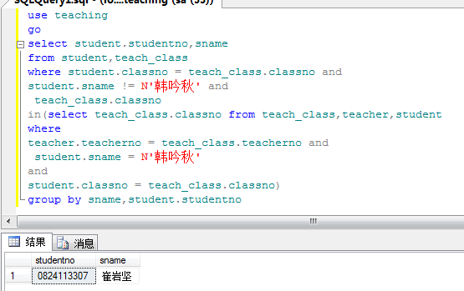
9.查询所有教授c05127号课程的教师信息。
use teaching
go
select teacher.teacherno,tname,major,prof,department from teacher
join teach_class on teacher.teacherno=teach_class.teacherno where courseno='c05127'
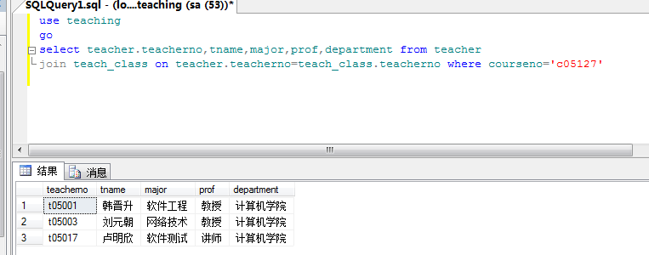
10.查询没有被任何学生选修的课程编号、课程名称和学分。
use teaching
go
select courseno,cname,credit from course
where not exists(select * from score
where score.courseno=course.courseno)
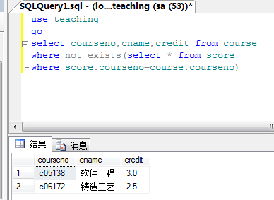
11.查询“C语言”课程期末成绩比“电子技术”课程期末成绩高的所有学生的学号和姓名。
use teaching
go
select test1.studentno,test1.sname from(
select student.studentno,sname,final
from student,score,course
where student.studentno = score.studentno and
score.courseno = course.courseno and
course.cname = N'C语言'
) as test1,(
select student.studentno,sname,final
from student,score,course
where student.studentno = score.studentno and
score.courseno = course.courseno and
course.cname = N'电子技术'
) as test2
where test1.final > test2.final and test1.studentno = test2.studentno
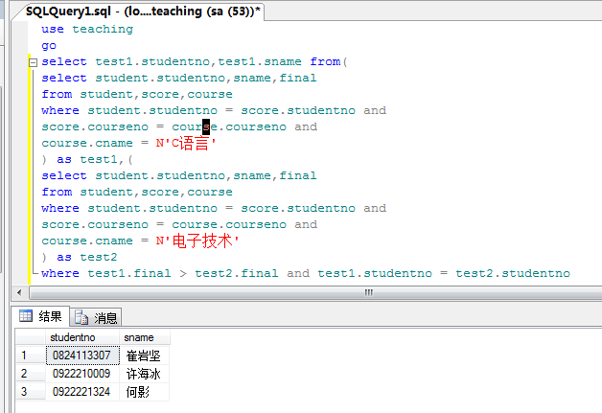
12．查询所有班级期末平均成绩的最高分，并将其赋值给变量，通过PRINT语句输出。
declare @high float
set @high =
(select top 1 tt.high from(
select avg(final) as 'high'
from student,score,course
where
student.studentno = score.studentno and
score.courseno = course.courseno
group by
student.classno
)as tt
)
print cast(@high as varchar(30))

select @high
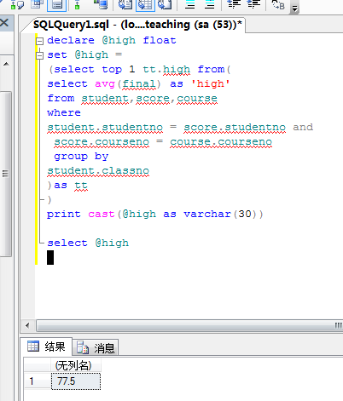
13.使用游标输出学生姓名、选修课程名称和期末考试成绩。
use teaching
go
declare @sname nchar(8),@cname nchar(8),@final numeric(6,2)
declare sc_cursor cursor for
select sname,cname,final
from score join student on(score.studentno=student.studentno)
join course on(score.courseno=course.courseno)
open sc_cursor
fetch next from sc_cursor into @sname,@cname,@final
print '学生姓名 课程名称 期末成绩'
print '---------------------------'
while @@FETCH_STATUS=0
begin
print @sname+@cname+cast(@final as nchar(6))
fetch next from sc_cursor into @sname,@cname,@final
end
close sc_cursor
deallocate sc_cursor
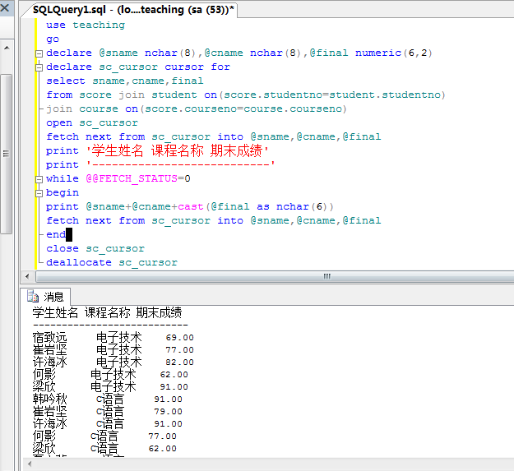
14.使用游标统计每个学院教师所开设课程的选修率。
use teaching
go
declare @department nchar(30),@num int,@avg float
declare cur cursor static
for
select department,count(*) as '选修课数' from class
where class.classno in(
select student.classno from student group by classno
)group by department
open cur
print @department
print @avg
while @@FETCH_STATUS =0
begin
fetch next from cur
into @department,@num
set @avg=@num/(select COUNT(*) from class where department=@department)
print @department
print @avg
end
close cur
deallocate cur
15.使用游标计算学生期末成绩的等级，并更新level列。
use teaching
go
declare @sname nchar(30),@cname nchar(30),@final float
declare stu cursor static
for
select sname,final,cname
from student,score,course
where student.studentno=score.studentno
and course.courseno=score.courseno
open stu
fetch stu
into @sname,@final,@cname
if @final>=90
print N'优'+@sname+@cname
else if @final>=80 and @final<90
print N'良'+@sname+@cname
else if @final>=70 and @final<80
print N'中'+@sname+@cname
else if @final>=60 and @final<70
print N'及'+@sname+@cname
else if @final<60
print N'差'+@sname+@cname
while @@FETCH_STATUS =0
begin
fetch next from stu
into @sname,@final,@cname
if @final>=90
print N'优'+@sname+@cname
else if @final>=80 and @final<90
print N'良'+@sname+@cname
else if @final>=70 and @final<80
print N'中'+@sname+@cname
else if @final>=60 and @final<70
print N'及'+@sname+@cname
else if @final<60
print N'差'+@sname+@cname
end
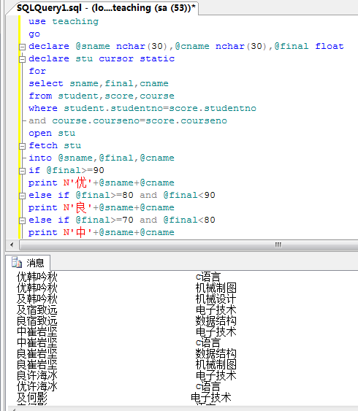
四、实验总结
1.内连接与外连接的功能及区别。
2.相关子查询与不相关子查询的功能及区别。
3.利用游标处理结果集的基本过程和方法。
注意：提交文档要求
凡不符合本条要求者，限时返回重写、重新提交，并大幅降低实验得分。
- 多次实验（每次实验写一个报告）
统一创建一个根文件夹，命名为学号_姓名如：200409020101_薛永海
- 每次实验
每次实验创建一个子文件夹，命名为实验序号如实验1，不再建它的子文件夹。
放入实验报告、程序文档，要求如下。
- 实验报告
Word2003格式（扩展名为DOC），文件名为实验序号_报告，例如：
实验1_报告.DOC
- 程序文档
需要将数据库分离后的所有数据文件和日志文件。
- 提交说明
根文件夹如200409020101_薛永海压缩为一个同名文件（RAR或ZIP格式）。

